

Capstone Project Report
Report 3 – Software Requirement Specification

– Ho Chi Minh, October 2026 –
Table of Contents
I. Project Report 3
1. Status Report 3
2. Team Involvements 3
3. Issues/Suggestions 3
II. Software Requirement Specification 4
1. Overall Description 4
1.1 Product Overview 4
1.2 Business Rules 5
2. User Requirements 6
2.1 System Actors 6
2.2 Use Cases 6
3. Functional Requirements 8
3.1 System Functional Overview 8
3.2 <<Feature Name 1>> 10
3.3 <<Feature Name 2>> 10
4. Non-Functional Requirements 11
4.1 External Interfaces 11
4.2 Quality Attributes 12
5. Other Requirements 14
5.1 Appendix1 - Messages List 14
5.2 Appendix2 - … 14
5.3 … 14

I. Record of Changes
Date | A*  M, D | In charge | Change Description
27/10/2026 | A | Phat | Create SRS version 1.0
*A - Added M - Modified D - Deleted

II. Software Requirement Specification

1. Product Overview
The AI Debate Practice Platform (ADPP) is a web-first learning platform for structured debate practice. It supports debates against an AI opponent, peer-to-peer debates with AI assessment, rubric-based feedback, rebuttal coaching, learning progress tracking, competitions, and prepaid AI-feature usage through payOS. The core application is web-based; a mobile application is optional. Debate topics are bounded to society, technology, and education in the initial scope.
The system integrates with an external AI/LLM service for argument generation and evaluation and with external services for payment and authentication as applicable. Its users include Debaters (also called Members in the supplied use-case diagram), Organizers, and Administrators. The diagrams below are source-provided conceptual models, not verified representations of the current production schema.

1.1 System Context
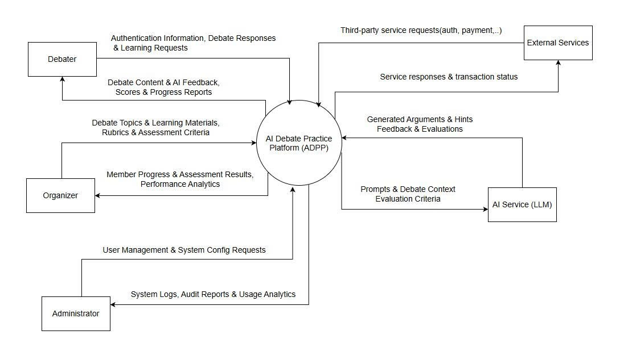1.2 Scope and Assumptions
Confirmed design decisions include single-elimination competition format; individual 1v1 and team 2v2 participation; two members required for a competition team to be eligible; match start by the organizer or assigned judge; AI-assisted scoring subject to human judge confirmation. Features described as proposed or pending verification must not be treated as implemented.

2. User Requirements

2.1 Actors

# | Actor | Description
1 | Debater | Registers, configures sessions, debates, receives coaching, reviews scores, purchases credits, joins competitions.
2 | Organizer | Manages debate topics, events, competitions, participants, judges and results.
3 | Administrator | Manages accounts, roles, rubric and platform/AI configuration; reviews monitoring.
4 | AI Service (LLM) | Generates opponent arguments, rebuttal suggestions and structured evaluations.
5 | External Services | Processes payments and returns verified transaction status; may provide authentication integrations.

2.2 Use Cases

2.2.1 Diagram(s)
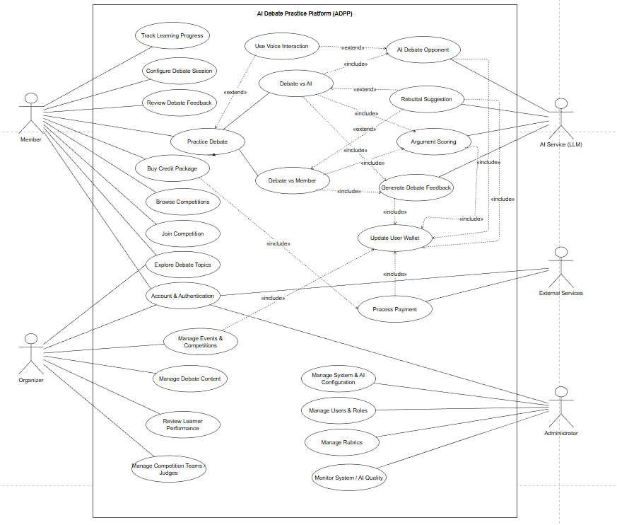

2.2.2 Descriptions
This part describes the use cases, you can follow the table form as below]
ID | Use Case | Actors | Use Case Description
01 | Authenticate account | Member, Organizer, Administrator | Sign in and access authorized functions
02 | Browse and search topics | Member | Filter motions by keyword, category and difficulty
03 | Configure debate session | Member | Choose motion, side, mode and AI difficulty
04 | Debate with AI | Member, AI Service | Run opening, rebuttal and closing rounds
05 | Debate with member | Member, AI Service | Conduct a two-person timed debate
06 | Request rebuttal coaching | Member, AI Service | Receive strategies and improvement suggestions
07 | Score debate arguments | AI Service | Apply five-criterion rubric and return explained scores
08 | Review feedback and progress | Member | View transcripts, reports and score trends
09 | Browse and join competition | Member | Discover eligible events and register
10 | Manage competitions | Organizer | Create brackets, rounds, matches and manage participants
11 | Judge and finalize match | Organizer / assigned judge | Review AI proposal and confirm official result
12 | Buy credit package | Member, External Services | Create payment and update wallet after verification
13 | Manage content and rubrics | Organizer, Administrator | Maintain motions, supporting materials and scoring rubric
14 | Manage users and roles | Administrator | Manage user access and permissions
15 | Monitor platform and AI | Administrator | Inspect logs and usage/quality metrics
16 | Use voice interaction | Member | Use speech-to-text input and text-to-speech output

3. Functional Requirements

3.1 System Functional Overview

3.1.1 Screens Flow
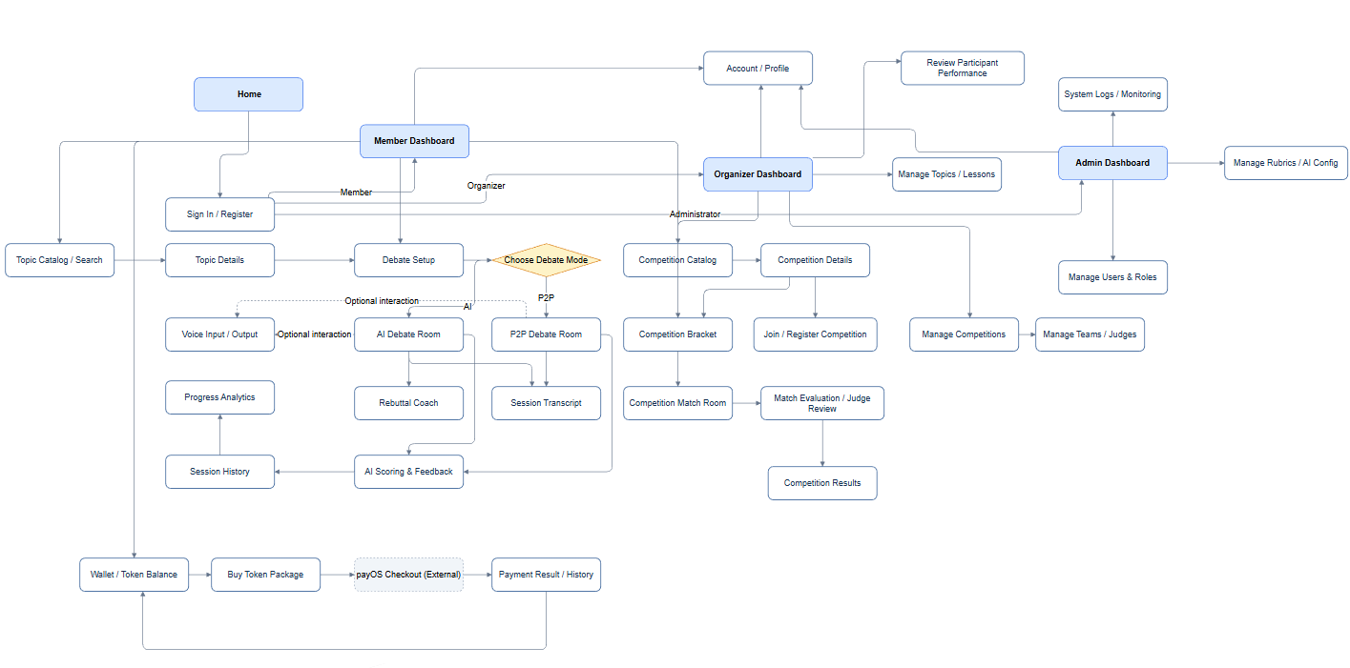

3.1.2 Screen Descriptions

# | Feature | Screen | Description
1 | Authentication | Login | Allows registered users to sign in to ADPP using their credentials.
2 | Authentication | Register | Allows new members to create an account.
3 | Authentication | Forgot Password | Allows users to request account recovery.
4 | Member | Member Dashboard | Provides access to debate practice, competitions, progress and wallet features.
5 | Member | User Profile | Displays and allows updates to the member profile.
6 | Topic Management | Topic Catalogue | Allows members to browse and search debate topics and motions.
7 | Topic Management | Topic Details | Displays the motion, category, difficulty and available learning material.
8 | AI Debate | Session Setup | Allows members to select topic, side, mode and AI difficulty.
9 | AI Debate | AI Debate Room | Displays timed debate rounds, arguments and AI opponent responses.
10 | AI Debate | Voice Interaction | Allows speech input and audio playback where supported.
11 | AI Coaching | Rebuttal Suggestions | Displays AI-generated rebuttal strategies and argument improvement hints.
12 | P2P Debate | Create / Join Debate | Allows members to create or join a debate with another member.
13 | P2P Debate | P2P Debate Room | Displays participants, assigned sides, round timer and submitted arguments.
14 | Debate Feedback | Feedback Report | Displays rubric-based scores, strengths, weaknesses and suggestions.
15 | Debate Feedback | Debate History | Lists previous sessions and provides access to saved transcripts and reports.
16 | Learning | Progress Dashboard | Shows a member’s debate performance and score trends.
17 | Competition | Competition Catalogue | Lists available competitions and their registration status.
18 | Competition | Competition Details | Shows competition rules, schedule, format and participation information.
19 | Competition | Competition Registration | Allows eligible members or teams to register for a competition.
20 | Competition | Match Details | Shows match participants, assigned judge, debate session and match status.
21 | Competition | Bracket / Results | Displays tournament progression, match outcomes and published results.
22 | Wallet & Payment | Wallet Overview | Displays prepaid token balance and recent transactions.
23 | Wallet & Payment | Buy Token Package | Allows members to choose a token package and initiate payOS checkout.
24 | Wallet & Payment | Payment Result | Displays payment confirmation or failure and updated transaction status.
25 | Wallet & Payment | Transaction History | Lists token purchases and recorded AI-feature usage.
26 | Organizer | Organizer Dashboard | Provides access to competitions, topics and performance information.
27 | Organizer | Manage Topics | Allows organizers to create and maintain motions and learning materials.
28 | Organizer | Manage Competitions | Allows organizers to create and update competitions and schedules.
29 | Organizer | Manage Teams & Participants | Allows organizers to review participants and team eligibility.
30 | Organizer | Manage Matches & Judges | Allows organizers to manage match assignments and assigned judges.
31 | Organizer | Judge / Finalize Match | Allows an authorized organizer or assigned judge to review scores and finalize a result.
32 | Administration | Admin Dashboard | Provides access to platform administration and monitoring.
33 | Administration | Manage Users & Roles | Allows administrators to manage accounts and role assignments.
34 | Administration | Manage Rubrics | Allows authorized administrators to maintain evaluation criteria.
35 | Administration | System Configuration | Allows authorized administrators to configure system and AI settings.
36 | Administration | Audit & Monitoring | Displays system activity, operational logs and monitoring information.

3.1.3 Screen Authorization

Screen | Member | Organizer | Administrator
Login / Register | X | X | X
Sign in / Create account | X | X | X
Request password reset | X | X | X
Member Dashboard | X | X | X
User Profile | X | X | X
View / update own profile | X | X | X
Topic Catalogue | X | X | X
Topic Details | X | X | X
Session Setup | X | — | —
Configure own debate session | X | — | —
AI Debate Room | X | — | —
Submit arguments / interact with AI | X | — | —
Voice Interaction | X | — | —
Rebuttal Suggestions | X | — | —
Create / Join Debate | X | — | —
P2P Debate Room | X | — | —
Feedback Report | X | — | —
View own feedback | X | — | —
Debate History | X | — | —
Progress Dashboard | X | — | —
Competition Catalogue | X | X | X
Competition Details | X | X | X
Competition Registration | X | — | —
Register self / team | X | — | —
Match Details | X | X | X
View assigned match | X | X | X
Bracket / Results | X | X | X
Wallet Overview | X | — | —
Buy Token Package | X | — | —
Payment Result | X | — | —
Transaction History | X | — | —
Organizer Dashboard | — | X | —
Manage Topics | — | X | X
Create / edit topics | — | X | X
Manage Competitions | — | X | —
Create / update own competition | — | X | —
Manage Teams & Participants | — | X | —
Approve competition registration | — | X | —
Manage Matches & Judges | — | X | —
Assign judge / schedule match | — | X | —
Judge / Finalize Match | — | X | —
Confirm score / finalize winner | — | X | —
Admin Dashboard | — | — | X
Manage Users & Roles | — | — | X
Create / update roles and accounts | — | — | X
Manage Rubrics | — | — | X
System Configuration | — | — | X
Audit & Monitoring | — | — | X

3.1.4 Non-Screen Functions
# | Service | Description
01 | Session state manager | Enforces valid session and round transitions and prevents duplicate start.
02 | AI opponent / coach adapter | Builds bounded prompts, handles timeout and parses structured output.
03 | Evaluation pipeline | Scores five rubric criteria and persists explained feedback.
04 | Tournament progression | Creates single-elimination brackets and advances confirmed winners.
05 | Payment callback handler | Verifies gateway response, applies idempotent wallet crediting.
06 | Audit and monitoring | Records sensitive actions and AI/payment failures.
07 | Real-time session channel | Synchronizes server-authoritative turns and countdown state.

3.1.5 Entity Relationship Diagram
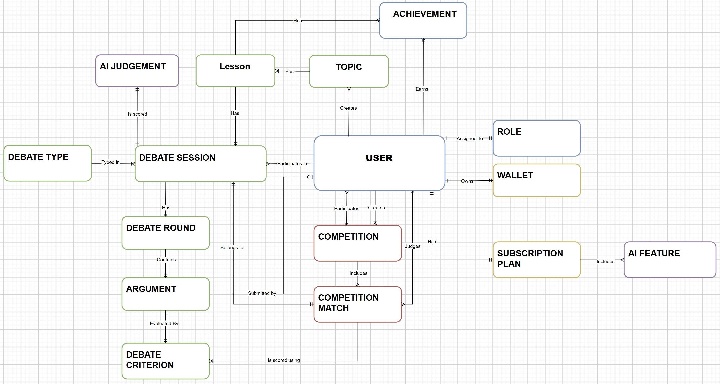
Entities Description
# | Entity | Description
1 | User | Stores user account information, including personal details, authentication credentials, and account status.
2 | Role | Defines user roles and permissions within the system, such as Member, Organizer, and Administrator.
3 | Wallet | Stores the user's token balance used to access paid AI features and services.
4 | Subscription Plan | Defines available service plans and the AI features included in each plan.
5 | AI Feature | Stores information about AI-powered functionalities, such as AI Opponent, AI Evaluation, and Rebuttal Suggestions.
6 | Topic | Stores debate topics, motions, categories, and related information used in debate sessions.
7 | Lesson | Stores educational materials and learning content associated with debate topics.
8 | Debate Type | Defines supported debate types, such as AI Debate and Member-to-Member Debate.
9 | Debate Session | Stores information about debate sessions, including participants, selected topics, debate formats, and session status.
10 | Debate Round | Represents individual rounds within a debate session, including round order, duration, and status.
11 | Argument | Stores arguments submitted by debate participants during debate rounds.
12 | Debate Criterion | Defines evaluation criteria used to assess debate arguments, such as Logic, Evidence, Relevance, Structure, and Persuasiveness.
13 | AI Judgement | Stores AI-generated evaluations, scores, and feedback for debate performances.
14 | Competition | Stores information about debate competitions, including competition details, organizers, participants, and status.
15 | Competition Match | Represents individual matches within a competition, including participants, assigned judges, match status, and results.
16 | Achievement | Stores achievements or awards earned by users through learning activities and debate participation.

3.2 Common Platform Services

3.2.1 User Registration and Authentication
Function Trigger: Public landing page → Register / Login; Forgot Password from Login.
Function Description: Visitor, Member, Organizer, Administrator. Provide account creation, sign-in, recovery and protected-session access.
Function Details – Inputs, Validation and Business Rules: Email, password, registration details; validate mandatory fields and email format; authenticate credentials and issue authenticated session/JWT.
Normal Flow: Valid registration creates an account; valid sign-in opens the role-appropriate dashboard.
Abnormal / Exception Flow: Duplicate account, invalid credentials, expired credentials or unavailable authentication service must produce an appropriate error without revealing secrets.
Screen Layout / Reference: Account / Authentication screens — insert approved UI screenshot or wireframe; not included in supplied sources.

3.2.2 Topic Search and Management
Function Trigger: Member → Topic Catalogue / Topic Details; Organizer → Manage Topics.
Function Description: Member searches and views motions; Organizer creates or updates topics and supporting materials.
Function Details – Inputs, Validation and Business Rules: Keyword, category, difficulty, title and description; validate required topic fields and permissions.
Normal Flow: Search returns matching motions; organizer saves a valid motion and it becomes available according to its status.
Abnormal / Exception Flow: No matching topics, invalid topic data, or insufficient role permissions are handled explicitly.
Screen Layout / Reference: Topic Catalogue / Topic Details / Manage Topics — insert approved UI screenshot or wireframe; not included in supplied sources.

3.3 WF-01 AI Opponent Debate

3.3.1 Configure and Start AI Debate
Function Trigger: Member Dashboard → Practice Debate → Session Setup → Start.
Function Description: Member chooses motion, side, supported format and AI difficulty; system creates a structured session.
Function Details – Inputs, Validation and Business Rules: Topic ID, debate side, format, AI difficulty; validate eligible topic, supported options and permitted access. A session starts only once.
Normal Flow: A valid setup creates a session and displays the opening round with its countdown.
Abnormal / Exception Flow: Missing selections, unsupported configuration, duplicate start or unavailable session state prevent starting.
Screen Layout / Reference: Session Setup / AI Debate Room — insert approved UI screenshot or wireframe; not included in supplied sources.

3.3.2 Submit Arguments and Receive AI Responses
Function Trigger: During an active AI Debate Room turn; optional microphone input.
Function Description: Member submits text or STT-transcribed speech; AI Opponent generates a contextual response for the assigned side.
Function Details – Inputs, Validation and Business Rules: Validate current participant, round/turn, nonempty argument, time constraints and available AI usage allowance; persist transcript and response.
Normal Flow: Valid argument is saved and an AI reply is displayed; opening, rebuttal and closing stages follow the selected format.
Abnormal / Exception Flow: Expired turn, duplicate submission, AI timeout, failed STT or insufficient tokens are reported without silently advancing the debate.
Screen Layout / Reference: AI Debate Room / Voice Interaction — insert approved UI screenshot or wireframe; not included in supplied sources.

3.4 WF-02 AI Rebuttal Coaching

3.4.1 Request Rebuttal Suggestions
Function Trigger: Member → Debate Room → Rebuttal Suggestions or preparation panel.
Function Description: Member requests optional AI coaching based on the opponent argument and current debate context.
Function Details – Inputs, Validation and Business Rules: Pass opponent argument, motion, side and conversation context to coaching service; check feature entitlement and token cost.
Normal Flow: System presents two or three suggested rebuttal strategies when service returns a valid response.
Abnormal / Exception Flow: Unavailable AI service, insufficient balance, invalid context or empty suggestions show an actionable error.
Screen Layout / Reference: Rebuttal Suggestions — insert approved UI screenshot or wireframe; not included in supplied sources.

3.4.2 Record Coaching Usage
Function Trigger: After successful paid coaching request.
Function Description: System records chargeable AI feature usage for billing transparency.
Function Details – Inputs, Validation and Business Rules: Associate user, feature, usage event and token amount; prevent charging twice for the same accepted request.
Normal Flow: Successful charge and suggestion delivery are reflected in wallet history.
Abnormal / Exception Flow: Duplicate event, billing failure or partial AI failure must not create duplicate deductions.
Screen Layout / Reference: Non-screen API / Wallet History — insert approved UI screenshot or wireframe; not included in supplied sources.

3.5 WF-03 AI Scoring and Feedback

3.5.1 Evaluate Debate Arguments
Function Trigger: When a submitted argument or completed session is sent for evaluation.
Function Description: AI Evaluator assesses arguments against five equal-weight criteria: Logic, Evidence, Relevance, Structure and Persuasiveness.
Function Details – Inputs, Validation and Business Rules: Each criterion is scored 1–5; generate explained per-criterion scores and overall normalized score on a 0–10 scale, using the agreed rubric.
Normal Flow: A valid evaluation is saved and linked to the relevant debate session or argument.
Abnormal / Exception Flow: Missing transcript, malformed AI response, scoring out of range or service failure must not be presented as a valid score.
Screen Layout / Reference: Evaluation Service (non-screen) — insert approved UI screenshot or wireframe; not included in supplied sources.

3.5.2 Generate Feedback and Progress Report
Function Trigger: Session completion → Feedback Report; Member Dashboard → Progress.
Function Description: Member reviews strengths, weaknesses, improvement suggestions, past transcripts and score trends.
Function Details – Inputs, Validation and Business Rules: Retrieve completed session, evaluation details and user history; restrict access to authorized records.
Normal Flow: Completed feedback becomes visible and progress history is updated.
Abnormal / Exception Flow: Pending evaluation, missing session or unauthorized history access displays a clear status/error.
Screen Layout / Reference: Feedback Report / Progress Dashboard — insert approved UI screenshot or wireframe; not included in supplied sources.

3.6 WF-04 P2P Debate with AI Judge

3.6.1 Create or Join P2P Debate
Function Trigger: Member Dashboard → Debate with Member → Create / Join Room.
Function Description: Two members join a shared debate room with affirmative and negative sides.
Function Details – Inputs, Validation and Business Rules: Validate room availability, membership, assigned side, supported format and session readiness.
Normal Flow: Two eligible participants join and the server establishes the structured debate session.
Abnormal / Exception Flow: Full room, duplicate join, unavailable opponent or inconsistent session state prevent invalid transitions.
Screen Layout / Reference: Create / Join Debate / P2P Debate Room — insert approved UI screenshot or wireframe; not included in supplied sources.

3.6.2 Conduct and Judge P2P Debate
Function Trigger: Active P2P Debate Room → final round completion.
Function Description: System manages real-time turns and countdowns, records both transcripts and requests an AI Judge evaluation.
Function Details – Inputs, Validation and Business Rules: Server-authoritative turns; persist each submission; evaluate both sides using a common rubric and store result (Win/Lose/Draw as applicable).
Normal Flow: After both sides finish, evaluation and result are displayed and recorded.
Abnormal / Exception Flow: Disconnected user, timeout, invalid turn, AI evaluation failure or simultaneous completion must be handled without double finalization.
Screen Layout / Reference: P2P Debate Room / Match Result — insert approved UI screenshot or wireframe; not included in supplied sources.

3.7 WF-05 Event and Competition Management

3.7.1 Create Competition and Register Participants
Function Trigger: Organizer Dashboard → Manage Competitions; Member → Competition Details → Join.
Function Description: Organizer creates a competition; eligible members or teams register for available slots.
Function Details – Inputs, Validation and Business Rules: Validate competition title, dates, eligibility, registration window and participant uniqueness. For team mode, require exactly two members to compete.
Normal Flow: Organizer publishes an eligible competition; member registration is recorded and processed according to competition rules.
Abnormal / Exception Flow: Closed registration, duplicate participation, ineligible team or unauthorized organizer action is rejected.
Screen Layout / Reference: Manage Competitions / Competition Details / Registration — insert approved UI screenshot or wireframe; not included in supplied sources.

3.7.2 Generate Bracket, Conduct Match and Finalize Result
Function Trigger: Organizer → Manage Matches; assigned judge / organizer → Match Details → Start / Finalize.
Function Description: Single-elimination rounds and matches connect to debate sessions; AI suggests scores and a human judge confirms the official winner.
Function Details – Inputs, Validation and Business Rules: Match preparation links at most one debate session; only organizer or assigned judge may start; atomic and idempotent state changes. Completed debate advances match to evaluation; authorized confirmation finalizes result and bracket progression.
Normal Flow: Eligible match starts once, debate completes, judge confirms scoring and next-round progression is recorded.
Abnormal / Exception Flow: Concurrent start, missing participants, invalid state, unauthorized judge or duplicate finalization cannot produce multiple sessions or winners.
Screen Layout / Reference: Bracket / Match Details / Judge & Finalize Match — insert approved UI screenshot or wireframe; not included in supplied sources.

3.8 WF-06 AI Usage Billing and Payment

3.8.1 Buy Token Package and Process Payment
Function Trigger: Member → Wallet → Buy Tokens → payOS checkout.
Function Description: Member purchases prepaid tokens through payOS; payment service creates and tracks a transaction.
Function Details – Inputs, Validation and Business Rules: Validate selected package and amount; create gateway request; verify callback authenticity and transaction status; credit wallet only for verified success.
Normal Flow: Successful verified payment increases balance once and records payment history.
Abnormal / Exception Flow: Cancelled, pending, failed or repeated callbacks do not credit tokens incorrectly.
Screen Layout / Reference: Wallet / Buy Token Package / Payment Result — insert approved UI screenshot or wireframe; not included in supplied sources.

3.8.2 Charge AI Usage and Display Wallet History
Function Trigger: On accepted paid AI-feature request; Member → Wallet / History.
Function Description: System deducts tokens for chargeable AI features and shows balance and transactions.
Function Details – Inputs, Validation and Business Rules: Validate sufficient balance, configured feature price and unique usage reference; update balance and ledger consistently.
Normal Flow: Valid charge is recorded and updated balance appears in wallet.
Abnormal / Exception Flow: Insufficient balance, duplicate usage event or transaction failure does not result in a negative or double-charged wallet.
Screen Layout / Reference: Wallet Overview / Transaction History — insert approved UI screenshot or wireframe; not included in supplied sources.

3.9 Administration and Governance

3.9.1 Manage Users, Roles and System Settings
Function Trigger: Administrator Dashboard → Manage Users & Roles / System Configuration.
Function Description: Administrator manages user access and supported configuration settings.
Function Details – Inputs, Validation and Business Rules: Check administrator permission, input constraints and audit metadata; log significant administrative changes.
Normal Flow: Authorized changes are saved and reflected in subsequent access decisions.
Abnormal / Exception Flow: Unauthorized actions, invalid roles and conflicting updates are rejected and logged.
Screen Layout / Reference: Manage Users & Roles / System Configuration — insert approved UI screenshot or wireframe; not included in supplied sources.

3.9.2 Monitor AI Quality and Official Results
Function Trigger: Administrator → Audit & Monitoring; Organizer / assigned judge → Match Review.
Function Description: Authorized personnel inspect operational logs, AI quality issues and official competition result decisions.
Function Details – Inputs, Validation and Business Rules: Access limited by role and match assignment; retain audit trail for official score confirmation or override.
Normal Flow: Reviewable records show decision provenance and relevant status.
Abnormal / Exception Flow: Missing logs, unauthorized access and already finalized decisions are handled without silently changing results.
Screen Layout / Reference: Audit & Monitoring / Match Review — insert approved UI screenshot or wireframe; not included in supplied sources.

4. Non-Functional Requirements

4.1 External Interfaces
Interface | Requirement
Web client | Responsive web UI communicating with ASP.NET Core REST/JSON API.
AI services | Python/FastAPI services for opponent, coaching and evaluation; contract validation and timeout handling.
Database | SQL Server as primary structured store; exact schema must be verified against current V0.7 script.
Payment | payOS gateway; authenticated callback verification and idempotent processing.
Real-time transport | Server-authoritative synchronization; protocol and implementation to be confirmed.
Voice | STT/TTS providers or components; exact provider to be confirmed.

4.2 Quality Attributes
Attribute | Requirement/verification
Security | JWT authentication, role checks, secrets outside source control, input validation, least-privilege and sanitized logs.
Reliability | No duplicate session starts or wallet credits; failed external calls preserve consistent state.
Performance | Response-time, concurrency and throughput targets require team-approved numeric acceptance thresholds.
Usability | Clear debate timer, round state, validation feedback and accessible navigation.
Maintainability | Versioned API contracts, modular services, pull-request review and automated tests.
Testability | Report 2 targets >=70% core unit coverage, all main integration interfaces, and >=90% planned system tests.
AI quality | Use fixed rubric, structured output, evaluation datasets and review of official competition scores.
Recovery | Reconnect and resume logic should reconcile against authoritative server state.

5. Requirement Appendix

5.1 Business Rules

ID | Rule Definition
BR-01 | Supported roles include Member/Debater, Organizer and Administrator.
BR-02 | Debate rubric contains five equally weighted criteria, each scored from 1 to 5.
BR-03 | Overall AI evaluation is reported on a 0–10 scale with explanation.
BR-04 | Competition format is single elimination (current project decision; verify final approved baseline).
BR-05 | Eligible 2v2 competition team must contain exactly two members.
BR-06 | Competition match start is restricted to organizer or assigned judge.
BR-07 | A match may not be started twice; session creation and state changes must be atomic/idempotent.
BR-08 | AI recommendations do not finalize official competition results; human judge confirmation is required.
BR-09 | Advanced AI features consume prepaid tokens according to configured pricing.
BR-10 | Only verified payOS successful transactions may credit wallet; repeated callback cannot double-credit.
BR-11 | The core client is web; mobile is optional.
BR-12 | Subscription plans and payment gateways other than payOS are excluded under Report 1.

5.2 Common Requirements
ID | Common Requirement | Description
1 | Authentication | The system shall authenticate users before granting access to protected functions.
2 | Role-Based Authorization | The system shall authenticate users before granting access to protected functions.
3 | Input Validation | The system shall validate required fields, data formats, and input constraints before processing requests.
4 | Error Handling | The system shall display clear error messages when an operation fails without exposing sensitive system information.
5 | Data Integrity | The system shall maintain consistency of user accounts, debate sessions, competition results, and payment transactions.
6 | Confirmation Dialogs | The system shall request confirmation before performing destructive or irreversible operations.
7 | Audit Logging | The system shall record important administrative actions and changes to official competition results.
8 | Session Management | The system shall prevent unauthorized access when authentication credentials are invalid or expired.
9 | Search and Filtering | The system shall support relevant search and filtering functions for debate topics and competitions.
10 | Payment Consistency | The system shall prevent duplicate wallet credits when processing repeated payment callbacks.
11 | AI Service Error Handling | The system shall notify users when AI services are unavailable and prevent incomplete results from being treated as valid evaluations.
12 | User Feedback | The system shall provide appropriate success, warning, and error notifications for user operations.

5.3 Application Messages List
# | Message code | Message Type | Context | Content
1 | MSG01 | In line | No search results | No search results.
2 | MSG02 | Field validation | Required field is empty | This field is required.
3 | MSG03 | Toast message | Account registration successful | Update asset(s) successfully.
4 | MSG04 | Inline – error | Incorrect login credentials | Invalid email or password.
5 | MSG05 | Toast message | Debate session created | Debate session created successfully.
6 | MSG06 | Toast – warning | Debate cannot start | This debate session cannot be started.
7 | MSG07 | Toast – error | AI service unavailable | AI service is temporarily unavailable. Please try again.
8 | MSG08 | Toast – success | Debate feedback generated | Your debate feedback is ready.
9 | MSG09 | Field validation | A competition registration is not eligible. | You do not meet the registration requirements.
10 | MSG10 | Toast – success | A competition registration is accepted. | Registration submitted successfully.
11 | MSG11 | Toast – error | A user attempts an action without sufficient permissions. | You do not have permission to perform this action.
12 | MSG12 | Toast – success | An organizer publishes a competition result. | Match result published successfully.
13 | MSG13 | Toast – error | A payment cannot be completed. | Payment failed or was cancelled.
14 | MSG14 | Toast – success | A verified payment is credited to the wallet. | Payment successful. Your wallet has been updated.
15 | MSG15 | Inline – warning | The member has insufficient tokens for a paid AI feature. | Insufficient token balance.
16 | MSG16 | Toast – success | A topic is created or updated. | Topic saved successfully.
17 | MSG17 | Confirmation dialog | A user requests deletion of a managed item. | Are you sure you want to delete this item?
18 | MSG18 | Toast – error | An unexpected server error occurs. | Something went wrong. Please try again later.
19 | MSG19 | Inline – warning | The assigned judge attempts to finalize an already finalized match. | This match result has already been finalized.
20 | MSG20 | Toast – success | A user profile is updated. | Profile updated successfully.

5.4 Other Requirements…

